Silkeborg, DENMARK & Todtnau, GERMANY, May 16th, 2022

**SENSOR SOLUTIONS**

**Wind Cluster ApS**, global distributor of wind turbine components and accessories, together with **Schlüter Automation & Sensor GmbH** and its Swiss representation **Melviri AG**, leading provider and distributor of sensor technology and automation, today announce the three companies have signed an agreement covering products for the global wind power segment and in particular for wind turbine manufacturers, operators, and energy companies throughout Europe, USA, Korea, Japan, China and India.

In Europe, USA and Asia, **Wind Cluster** is a one-stop shop for turbine manufacturers and operators, offering a wide variety of components and accessories to the global wind power industry. Wind Cluster operate through a network of offices in Denmark, USA, China, India and Korea.

**Schlüter** is your problem solver for sensor technology and automation.

For more than 5 decades **Schlüter** have been offering customers solutions in the following areas:

* Optoelectronic sensors
* U-system photosensors - universal photosensors with and without fiber optics
* High-performance through-beam photoelectric switches
* Reflex light barriers
* Fork light barriers
* Frame light barriers
* Inductive sensors (subminiature, high performance, temperature resistant)
* Capacitive sensors (subminiature, temperature resistant ...)
* Sensors for the food industry (IP69k, stainless steel ...)
* Magnetic field sensors (temperature-resistant, acid-resistant)
* High temperature sensors and light barriers
* Special solutions in sensor technology
* Robots and linear axes

**Schlüter** offers 50 years of experience in sensor technology and process automation. Experience that you can use to your advantage.

**Schlüter Automation & Sensor GmbH**: History & expertise

In 1967 Lothar Schlüter, father of the current managing director Jens Schlüter, and still active in the company, founded Lothar Schlüter KG an industrial agency in Lehrte near Hanover, the then Lothar Schlüter KG, was at the forefront in the sensor business, already selling optical and inductive sensors.

As early as 1977, Lothar Schlüter and his colleagues at the time developed the first photo sensor in the M30 housing. Shortly afterwards, the first fiber optics were installed on the devices. This resulted in the Photo Sensor Universal System, or U-System for short, in 1981, which made the use of fiber optics and photo sensors even easier and more flexible. These fiber optics enable the use of high-performance photo sensors as reflex scanners or one-way light barriers, even in hard-to-reach places or under difficult environmental conditions such as heat, pressure, dust, fog, dirt, moisture, etc. Thanks to its high performance and flexible application options, the U-System quickly established itself on the market.

In the course of time, the production and delivery program was expediently expanded and supplemented with many components from the field of sensor technology. This is how **Schlüter** produces and supplies many innovative products that are unique on the market. For example, inductive sensors that work up to + 250 ° C, special light barriers for industrial ovens or capacitive special sensors for a wide variety of applications. Many products have been and are specially developed for customer-specific requirements and applications.

**We at Wind Cluster, together with the experience and expertise of Schlüter, are looking forward to helping YOU find the best product for your specific needs.**

At **Wind Cluster** we are proud to boast a vast range of products for the wind power industry, for many different applications, for use on small private owned turbines to large leading OEM windfarms. By creating lasting partnerships and distributing products for companies such as **Schlüter Automation & Sensor GmbH** we can not only offer the parts, but also the knowledge and expertise which accompany them.

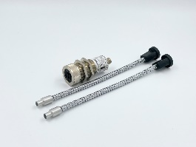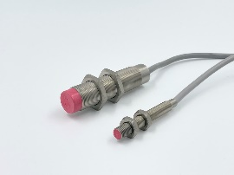Ein Bild, das Text enthält.
